**Traffic Congestion Simulation**

By: Justin Olson & Ni Li

**TABLE OF CONTENT**

1. Abstract
2. Background and Description of Problem
3. Materials & Methodology
4. Key Findings
5. Conclusions
6. Sample Simulation Modeling
7. Appendix with miscellaneous tables, figures, etc.
8. **Abstract**

Saint Paul, Minnesota is home to the Xcel Energy Center, an event center which hosts national hockey games and celebrity musical artists. The Xcel center has a capacity of 17,000 and even smaller events attract thousands of attendees. This pushes the road network in downtown Saint Paul to reach capacity, resulting in traffic jams. Traffic jams increase driver stress, increase carbon emissions per mile traveled, and gridlock critical emergency and police services. We use OpenStreetMap to capture the road network of downtown Saint Paul. The we apply SMARTS simulation software to replicate traffic under normal conditions and understand common traffic behavior and restrictions. Then, we conduct experiments to understand pre-event traffic flow, when many attendees are traveling to the venue at once. We tested the relationship between fixed and dynamic traffic lights under traffic loads of 100, 500, and 1,000 vehicles. We found that average travel speed was primarily limited by traffic load and not traffic lighting scheme. These results suggests that efforts to reduce traffic congestion surrounding events should aim to increase the arrival window to the venue.

1. **Background and Description of Problem**

Saint Paul, Minnesota has an estimated population of 308,096 and is the 11th-most populous city in the Midwest. If you're visiting St. Paul, there is a good chance you'll visit downtown. It's home to the thrilling restaurants, celebrations, and venues.

Among those venues is the Xcel Energy Center, an event center with a 17,000-person capacity. The venue is the official home of the Minnesota Wild hockey team and frequently features musical artists such as Harry Styles, Halsey, and The Weekend. The venue booked frequently, with events occurring 8-12 times per month.

The Xcel Energy Center is a popular entertainment destination. The large number of attendees coming to or leaving the venue led the streets to be saturated with vehicles. The effects of this unusually high traffic are compounded by the many one-way streets, which restrict traffic flow and cause jams to persist.

Traffic jams are a poor use of peoples' time and may lead to stress and frustration. According to a report published by *Texas A&M Transportation Institute* in 2019, the average commuter wastes 54 hours a year in traffic delays (*CNN, Cable News*). Additionally, traffic jams lead to the unnecessary production emissions, and gridlock vital services including the police, first responders, and Domino's pizza delivery.

Simulation is an effective modeling tool that allows the user to gain insight into phenomenon in which randomness is involved. Discrete event simulation tools such as Arena software can be used to model scenarios involving arrivals. However, in this framework the user must specify roads, traffic lights, and vehicle flow. For small or confined scenarios such as a single intersection, Arena is a very useful tool. When scaled to a larger grid, such as a section of a city, Arena becomes cumbersome.

Scalable Microscopic Adaptive Road Traffic Simulator (SMARTS) is a traffic simulation software developed by the University of Melbourne that allows for flexible traffic simulation that can handle various types of traffic data and is scalable across distributed systems [1]. SMARTS has demonstrated utility in determining urban traffic interventions [2], performing traffic optimization [3], behavioral simulation [4], simulating emergency vehicle prioritization [5], and the optimization of autonomous vehicles [5]. Therefore, we elected to use SMARTS simulation software to generate data and simulate traffic data1.

1 *Our team elected to simulate traffic data rather than collect it as data collection is time consuming and inaccurate. Without an extensive set-up, it is difficult to both measure and record arrival times across several streets at once and to accurately record traffic light patterns and timing all at once. Instead, we elected to spend more time in the intelligent design and execution of simulation experiments and rely on the seemingly reasonable assumptions of SMARTS traffic simulation software.*

1. **Materials & Methodology**

OpenStreetMap is an open-source project containing street maps from around the world. We used OpenStreetMap to extract the road network by locating downtown Saint Paul and selecting a bounding box with the latitude [44.9619 to 44.9360] and longitude [–93.137 to –93.0653]. The respective data file was downloaded and imported into SMARTS simulation software.

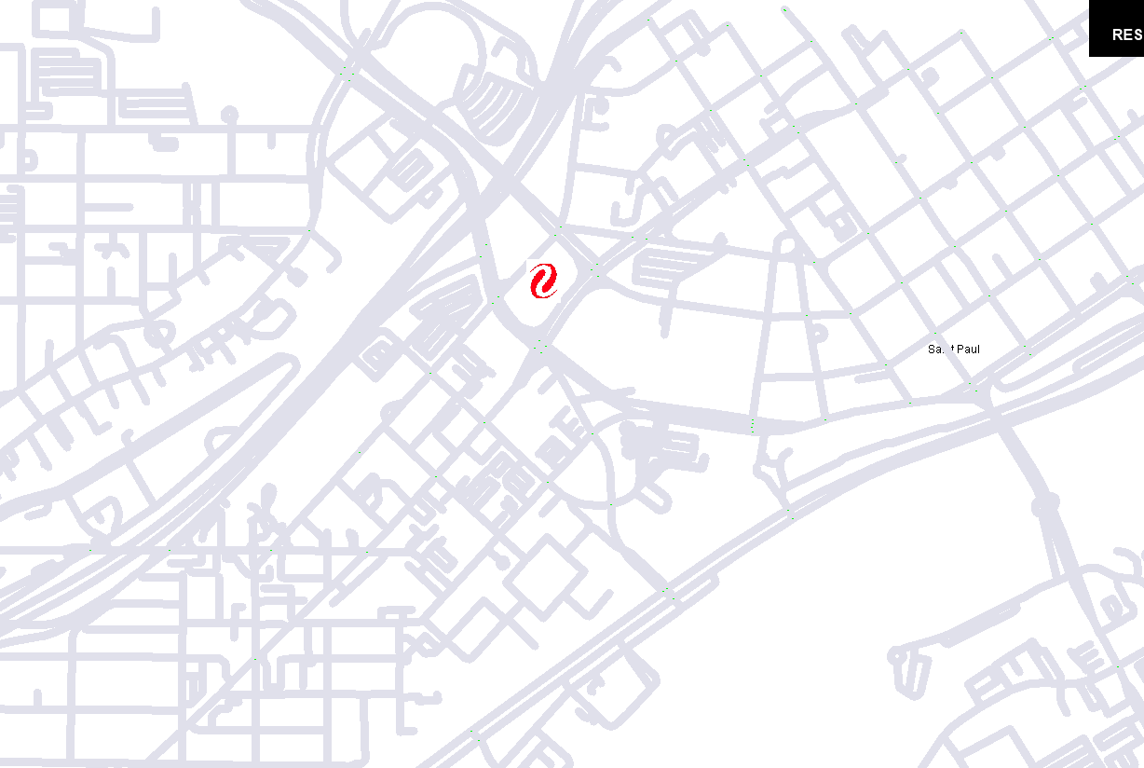

**Figure 1:** OpenStreetMap of Saint Paul, as represented within SMARTS simulation software. The Xcel Energy Center is represented by the red icon.

1. **Key Findings**

**Understanding Steady State Traffic**

Exploring causes of Traffic in steady state traffic in the downtown Saint Paul area. This allows us to understand traffic flow in the absence of traffic flow towards the Xcel Center to understand normal, day-to-day traffic flow.

The purpose of these simulation experiments is to better understand how structural characteristics such as traffic light frequency, driver behavior, and structural limitations give rise to normal traffic conditions. To modify the real situation, we used 500 random background private vehicles, 5 random background buses, 1200 maximum number of steps with 1 step per second, fixed traffic timing, Dijkstra routing algorithm for new routes as our simulation settings.

Using SMARTS, we defined several root causes of traffic congestion:

1. Too much traffic for the available physical capacity to handle due to the poorly intersection design. **Figure 2** (below) is a screenshot of our simulation shows the real time traffic condition at two of the intersections near Xcel Energy Center. Both observation 1 and 2 shows the traffic flow breaks down at one intersection. There are close by intersections are so close, which restrict the space between these two intersections to accommodate the waiting cars at the first intersection. Then, the adjacent intersection gets affected and congested as well. Slowly, the trend of congestion keeps spreading around the area, fewer and fewer cars can get through those intersections. These locations eventually become bottleneck with the flow of traffic.

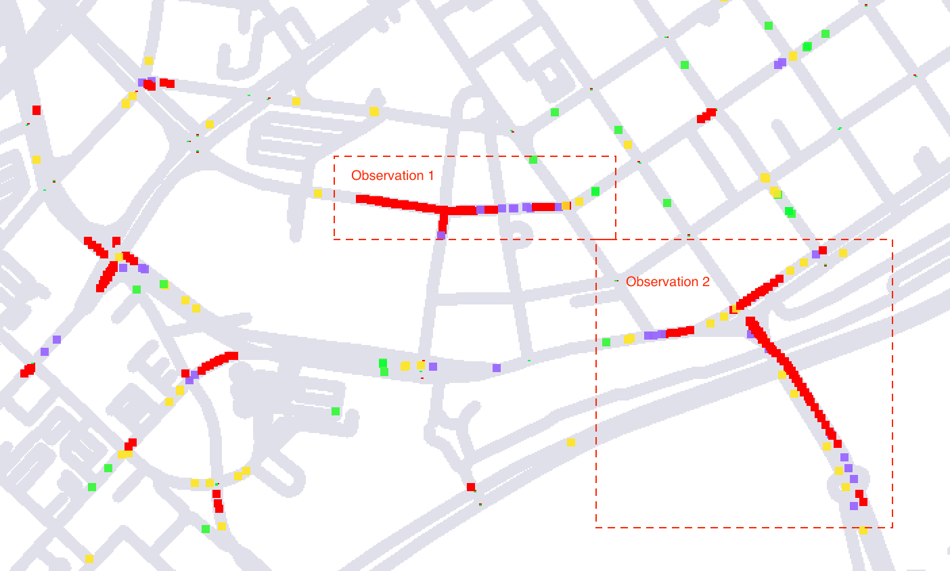

**Figure 2:** traffic congestion affecting multiple intersections

1. Traffic lights signals are poorly timed at certain intersections. For instance, if you follow a car who hit a red light at one of the intersections in the triangle area labeled as observation 3 in **Figure 3** (below), you will notice this car will possibly hit red light at the next intersection in the triangle area. This can be caused possibly by hysteresis loops on the road. The traffic lights for a continuous speed. If a car was lucky enough to make it through the first one on green, and most likely this car will catch every green light thereafter. However, the traffic management system was not smart enough to avoid car getting every red light all the way through.

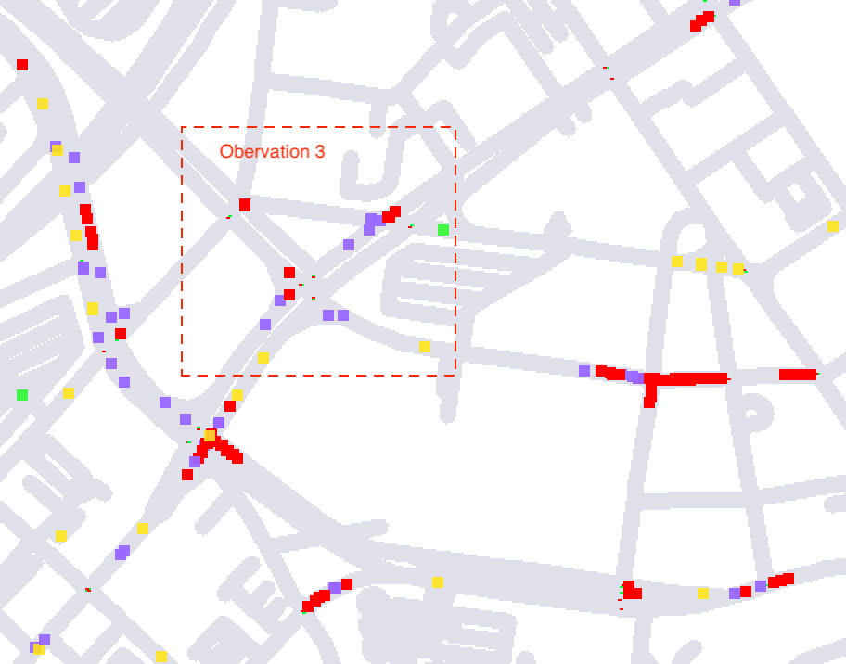

Figure 3: Traffic congestion at the triangular roads

1. Another problem we have observed is that if the traffic flow at one direction tends to be heavier than the other direction, this situation will continue and even getting worse on the heavy traffic direction. For example, at the observation 1 location in figure 2 above, the traffic jam starts on the street which runs from east to west. Then, the traffic on the street keeps getting heavier and heavier until both east to west and north to south direction get clogged. According to the traffic needs, the traffic lighting system should be adjusted dynamically to extend the green light timing in the direction which has a much heavier traffic than the other one since that direction start jamming. In that way, there are more cars can be released at the beginning, which can help with the traffic when the road gets busier.

With the real-time traffic monitoring using SMARTS, we can illustrate where and when the heavy traffic occurs, where public buses, taxis, other modes of transit are located, and other insight detailed data to reflect the specific needs in traffic control for each location. All the information can be used in monitoring for creating smart traffic management system like **Figure 4** (below) and eventually make travel throughout the city more efficient and environmentally sustainable.

**Figure 4:** Block Diagram of the smart traffic management system

**Characterizing Xcel Center-based Traffic Jams**

We conducted experiments to study traffic flow from the greater downtown area to the Xcel Energy Center. This was conducted by selecting a destination bounding box representing an area directly adjacent to the Xcel Energy Center, which contains parking ramps that are common arrival destinations for attendees. We compared dynamic lighting control to fixed traffic control under varying traffic loads. We selected traffic loads of 100, 500, and 1,000 vehicles for our simulation. Where 100 vehicles serves as a low-load baseline, 500 vehicles represent moderate load, and 1,000 vehicles represents a high load scenario.

|  |  |  |
| --- | --- | --- |
| **Traffic Light Timing** | **Number of Vehicles** | **Average Travel Speed (km/h)** |
| **Dynamic** | **100** | **13.9** |
| **Dynamic** | **500** | **5.8** |
| **Dynamic** | **1000** | **3.7** |
| **Fixed** | **100** | **14.3** |
| **Fixed** | **500** | **5.7** |
| **Fixed** | **1000** | **3.7** |

***Table 1:*** *Average Travel Speeds during Travel to the Xcel Center destination under Dynamic and Fixed Traffic Lighting*

The results of our experiment our presented in **Table 1** (above) and indicate that travel speed is highly similar between dynamic and fixed lighting schemes. Conversely, low travel speeds are highly correlated with the number of vehicles on the road. Together, these results suggest that the traffic issue is more likely a function of the existing infrastructure limitations rather than unintelligent traffic light schemes. Visual inspection of traffic across the downtown Saint Paul road network at the conclusion of the simulation can be found in **Figure 5** (below). These results demonstrate that congestion occurs at similar locations under both conditions regardless of the lighting system used, suggesting physical limitations of the network.

Congestion appears highly similar across n = 100 and n = 500 for both dynamic and fixed traffic light controls. However, traffic appears notably worse for the fixed traffic system at n = 1,000. These results suggest that as traffic volume increases, lighting control becomes a more significant factor.

It is interesting that the traffic backlog reflected for the fixed traffic light control at n = 1,000 is not represented by the travel speed. These results represent the traffic load at the conclusion of the simulation, not when every vehicle has reached their destination. It could be that slower travel times are occurring in the fixed light scenario but that longer simulation times are necessary to capture them. A future direction of our work is to extend the duration of our simulation to see if differences between traffic light conditions become more pronounced.

**Dynamic Traffic Light Control**

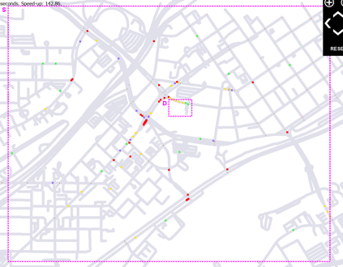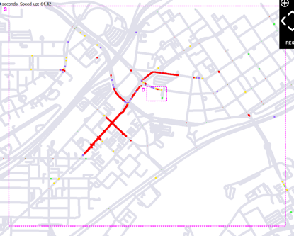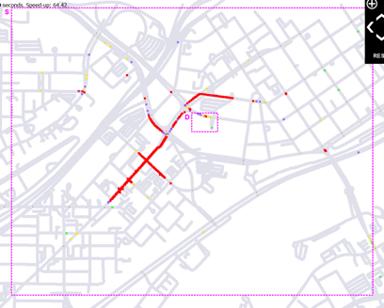

***n = 100*** ***n = 500*** ***n = 1,000***

**Fixed Traffic Light Control**

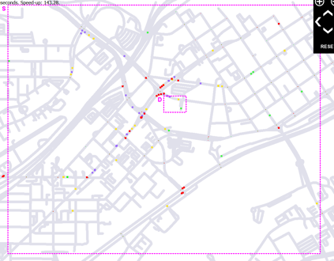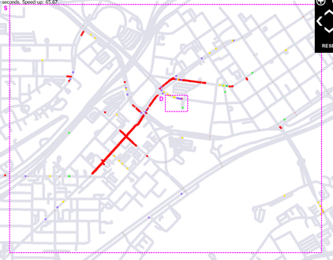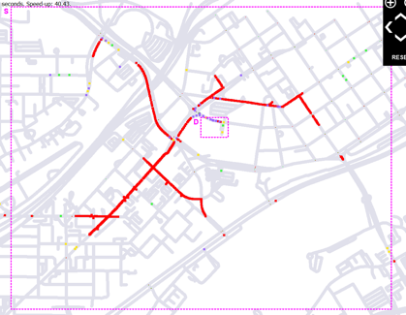

***n = 100*** ***n = 500*** ***n = 1,000***

***Figure 5:*** *Dynamic vs Fixed Traffic Light Control under vehicle capacities of 100, 500, and 1,000. Results indicate traffic conditions at the end of the simulation.*

1. **Conclusion**

Traffic congestion is an important and challenging real-world problem, which aims to minimize the travel time of vehicles especially at the road intersections. Traffic will continue to plague cities as more drivers hit the roads each year. However, current traffic signal control systems in use still rely heavily on oversimplified information and rule-based methods, although we now have richer data, more computing power and advanced methods to drive the development of intelligent transportation. With the growing interest in intelligent transportation using simulation modeling tool like SMARTS, can help us getting the insight detailed information for smart traffic management technologies development without widening roads. We all should continue to look into cutting-edge technology to help the city planner and transportation engineers to build a better future for our growing urban centers.

1. **Sample Simulation Modeling**

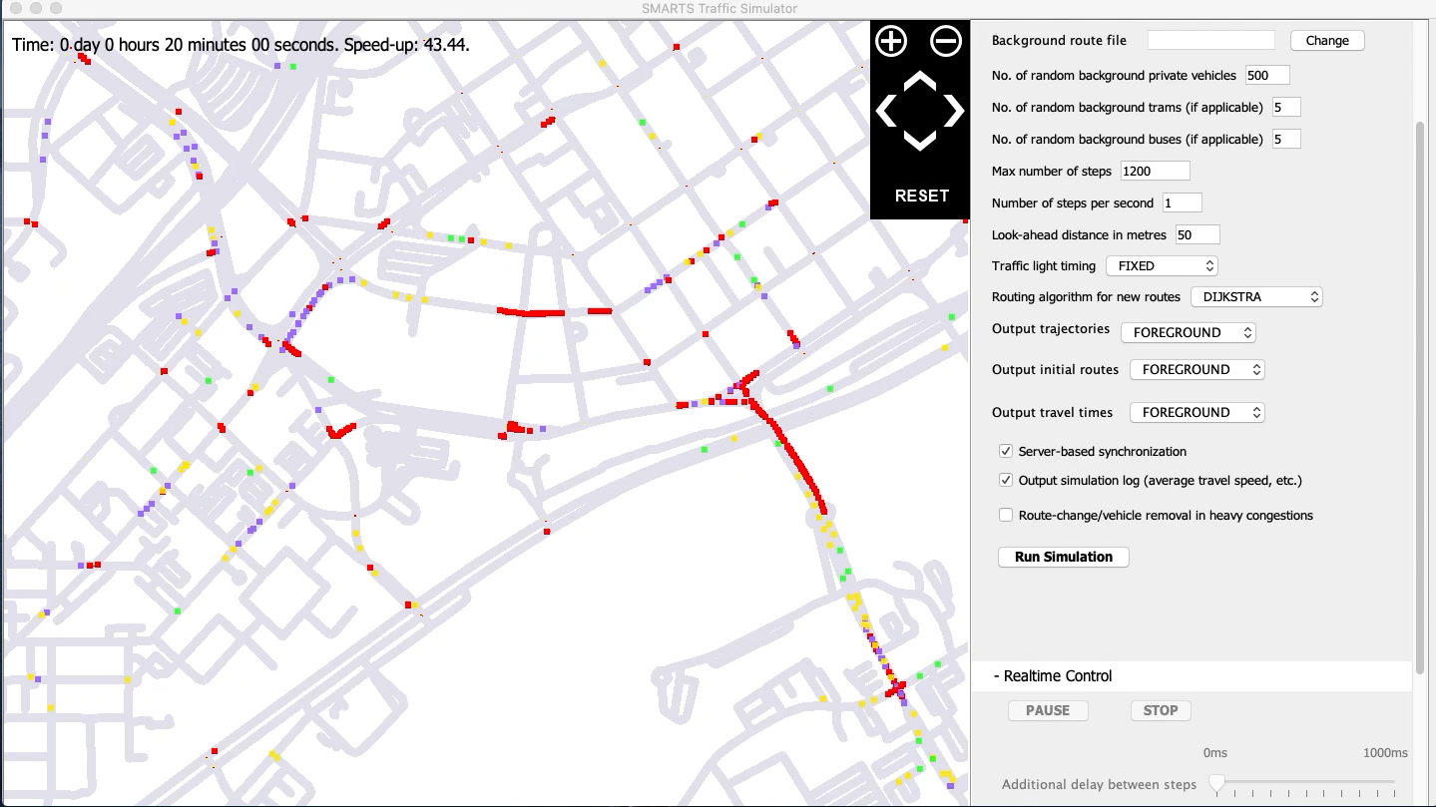Our sample simulation modeling shows below:

Background sample code in Java script:

1. **References**
2. Kotagiri Ramamohanarao, Hairuo Xie, Lars Kulik, Shanika Karunasekera, Egemen Tanin, Rui Zhang, and Eman Bin Khunayn. 2016. SMARTS: Scalable Microscopic Adaptive Road Traffic Simulator. ACM Trans. Intell. Syst. Technol. 8, 2, Article 26 (January 2017), 22 pages. DOI:https://doi.org/10.1145/2898363
3. Xie H, Karunasekera S, Kulik L, Tanin E, Zhang R, Kotagiri R. A Simulation Study of Emergency Vehicle Prioritization in Intelligent Transportation Systems. 2017 IEEE 85TH VEHICULAR TECHNOLOGY CONFERENCE (VTC SPRING). IEEE. 2017, Vol. 2017-June. DOI: 10.1109/VTCSpring.2017.8108282
4. Wang XM, Leckie C, Xie H, Vaithianathan T. Discovering the Impact of Urban Traffic Interventions Using Contrast Mining on Vehicle Trajectory Data. 19th Pacific-Asia Conference on Knowledge Discovery and Data Mining (PAKDD). Springer Verlag. 2015, Vol. 9077. Editors: Cao T, Lim EP, Zhou ZH, Ho TB, Cheung D, Motoda H. DOI: 10.1007/978-3-319-18038-0_38
5. Xie H, Karunasekera S, Kulik L, Tanin E, Zhang R, Kotagiri R. A Simulation Study of Emergency Vehicle Prioritization in Intelligent Transportation Systems. 2017 IEEE 85TH VEHICULAR TECHNOLOGY CONFERENCE (VTC SPRING). IEEE. 2017, Vol. 2017-June. DOI: 10.1109/VTCSpring.2017.8108282
6. Kotagiri R, Qi J, Tanin E, Motallebi S. From How to Where: Traffic Optimization in the Era of Automated Vehicles (Vision Paper). GIS: Proceedings of the ACM International Symposium on Advances in Geographic Information Systems. 2017, Vol. 2017-November. DOI: 10.1145/3139958.3139997
7. Willingham, AJ. “Commuters Waste an Average of 54 Hours a Year Stalled in Traffic, Study Says.” *CNN*, Cable News Network, 22 Aug. 2019, www.cnn.com/2019/08/22/us/traffic-commute-gridlock-transportation-study-trnd.
8. Roos, Dave. “Why Syncing Stop Lights May Not Solve Traffic Woes.” *HowStuffWorks*, HowStuffWorks, 24 Oct. 2018, auto.howstuffworks.com/car-driving-safety/safety-regulatory-devices/why-syncing-stop-lights-may-not-solve-traffic-woes.htm.